# How to run the 717 Synthesis Report Generation tool

## 1. Check if you completed the set-up

* Everything in this document should have been completed before you run the tool.

## 2. Open the tool folder (717 automation).

## 3. save your data consolidation sheet into the “data” folder.

## 

## 4. in the 717 automation folder, open R project by double-clicking .

* This should open up the R studio.

## 5. go to the “files” tab on the bottom-right pane. click on A screenshot of a computer Description automatically generated to open the R script.

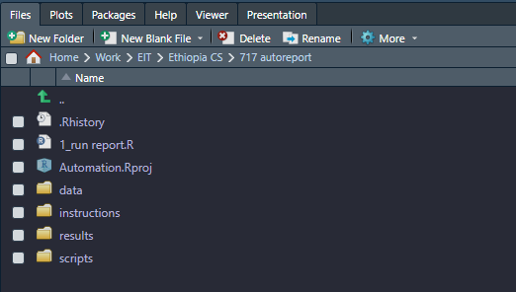

## 6. Setting up

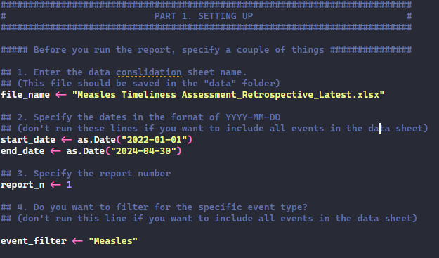

* Enter the data consolidation sheet name into **file_name.**
* If you want to specify the reporting time frame, change the **start_date** and **end_date** values and run each line (Ctr+Enter).
* Specify the report # by changing the number in **report_n** and run the line (Ctr+Enter).
* If you don’t want to specify anything, skip this part.

## 7. Run the report

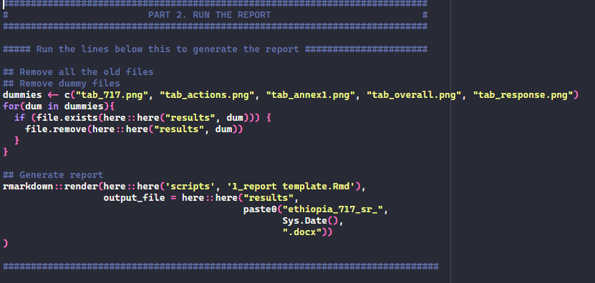

* Before running, make sure the excel datasheet is not open.
* Select the entire part 2 and Ctr+Enter to run them.
* At the console panel (bottom left), you will see the line **“Output created ….”** once the report generation is complete.

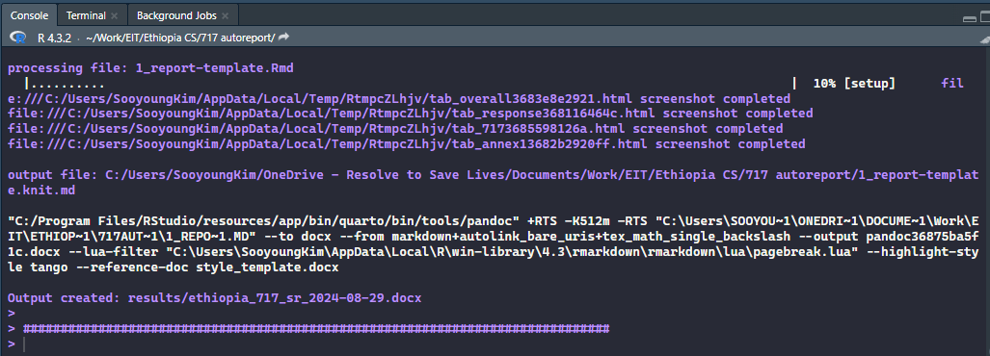

* The generated report will be saved in the “results” folder with today’s date in the file name.